COMPANY ReOC Application
Additional information needed and submission checklist

Additional Information
Please send a completed copy of this page along with Form 101-06 and the documentation listed on the following page when you are ready to go ahead with the application.
We need the following information to produce the ReOC Operations Manual and other CASA checks.

Company Details
A.C.N. (9 digits)
A.B.N. (11 digits)
Operational / Street Address
Registered or Postal Address
Phone
Email

Chief Remote Pilot
Street Address

Intended Operations
Main intended use of RPA. | ☐ aerial photography and cinematography  ☐ aerial agriculture  ☐ asset inspections  ☐ building and structure washing  ☐ mapping and surveying  ☐ research and development  ☐ other  Please describe:

ReOC Record Keeping
How do you intend to keep your records? | ☐ Paper based  ☐ Office computer  ☐ Cloud based document storage  ☐ Electronic compliance management system  Which one?  e.g.AVCRM, Flyfreely, Drone Logbook

RPAS Details
Please list the RPAS that you want to have included in your ReOC manuals.
Make | Model

Documentation checklist to be sent with the application
☐ Form 101-06 – completed and signed by the CEO or a company director
☐ Copy of the Chief Remote Pilot’s Remote Pilot Licence showing:
☐ Name
☐ ARN
☐ Date of Birth
☐ Ratings held on the licence

A screen capture or multiple screen captures of portions of the RePL may be provided instead of the RePL. We need all the details noted above.
The QR code from the CASA digital licence is not sufficient on its own.
Portal example | Digital Licence Example
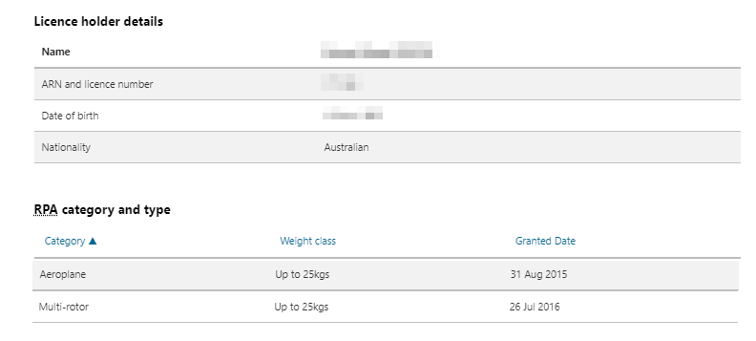 | 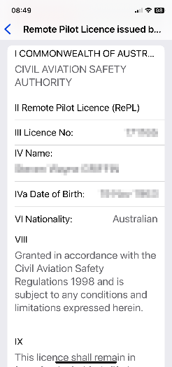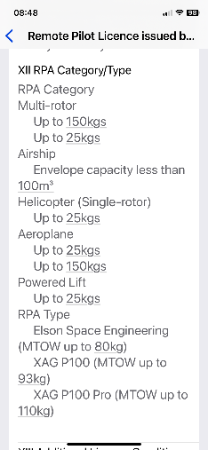

☐ Document issued by CASA showing the company name and ARN or a screenshot from the CASA portal showing the company name and ARN
☐ If the CEO is someone other than the CRP, a copy of a document issued by CASA showing the CEO’s name and ARN or a screenshot from the CASA portal showing the CEO’s name and ARN
☐ If the Maintenance Controller (MC) is someone other than the CEO or CRP, a copy of a document issued by CASA showing the MC’s name and ARN or a screenshot from the CASA portal showing the MC’s name and ARN

